Summer Update from the
Sussex Green Team!

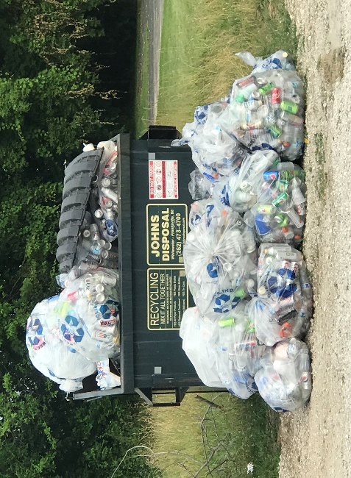
The Sussex Green Team has been busy this summer! Sussex Lions Daze was the weekend of July 19-21, and SGT members worked with Waukesha County Recycles to place additional recycling bins around the festival grounds. We saved 29 bags of recyclables from the landfills! Thank you to the Sussex Lions Club and the Sussex Area Service Club for again working with us on this project.
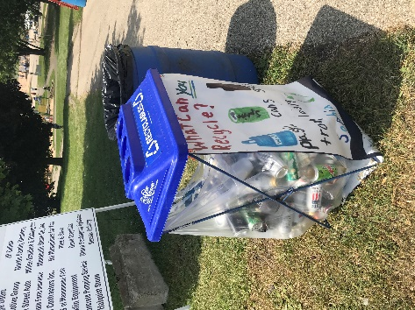

We are partnering with the Village of Sussex to promote environmentally-friendly practices at the traveling beer gardens around the Village all summer long. Visitors who walk or bike from home receive $1 off of their first beer, reusable mugs are available for purchase on-site and receive a discount on refills! Find more information at the Pints in the Park website.

SGT members will also be working with Sussex Outreach Services and the Sussex Farmer’s Market vendors to pick up fresh, local produce for people in need in our community. To learn more about these programs, visit SOS or Sussex Farmer’s Market.

SGT has signed up with Waukesha County’s Adopt A Trail program to begin more consistent cleanups of the Bugline Trail through Sussex. We’re currently planning a Youth Action Day to encourage area youth groups to participate in this event. More info soon!

Interested in learning more about our group or joining our team? Visit our Facebook page, find us on Twitter, or email us at sussexgreenteam@gmail.com, or join us at our next meeting! We meet on the following dates at 6:30pm in the Pauline Haass Public Library: Tuesday, August 13, Wednesday, September 11, and Wednesday, October 9.

